Wear and Appearance of Uniforms

GENERAL GROOMING (lAW AR 670-1 and CC Reg 670-1)

All cadets will maintain a high standard of dress and appearance. Uniforms will be properly fitted (trousers, pants, or skirts should not fit tightly), clean, serviceable, and pressed as necessary. Personnel must project a military image that leaves no doubt that they live by a common military standard and are responsible to military order and discipline. Cadets will ensure that when articles are carried in pockets; i.e., wallets, checkbooks, combs, and keys, these articles do not protrude from the pocket or present a bulky appearance. Items such as keys and key chains will not be attached to belt loops or belts. While in uniform, personnel will not place their hands in their pockets except momentarily to place or retrieve objects.
Uniforms will be kept buttoned, zipped, and snapped; metallic devices such as metal insignia, belt buckles, and belt tips will be kept in proper luster and will be free of scratches and corrosion; medals and ribbons will be clean and not frayed; and shoes and boots will be cleaned and shined. Lapels and sleeves of coats and jackets will be roll pressed (without creasing). Skirts will not be creased. Trousers, slacks, and sleeves of shirts and blouses will be creased. No other lines/creases will be ironed into the shirt. Although some uniform items are made of wash-and-wear materials or treated with a permanent press finish, some pressing may be required to maintain a neat military appearance. However, before pressing, soldiers should read and comply with care instruction labels attached to uniform items. ACUs are not to be ironed.
The wearing of a combination of civilian and military clothing is prohibited. Commercial rucksacks, gym bags or like articles may be worn over the shoulder while in uniform as long as the articles are black in color and have no conspicuous logos.
The wear of Army uniforms is prohibited in connection with the furtherance of any political or commercial interests or when engaged in off-duty civilian employment, when participating in public speeches, interviews, picket lines, marches, rallies, or public demonstrations, when attending any meeting or event which is a function of, or is sponsored by, an extremist organization, when wearing the uniform would bring discredit upon the Army.
These appearance standards apply in all uniforms.

HAIR
There are many hairstyles that are acceptable in the Army. So long as the Cadet's hair is kept in a neat, clean manner, the acceptability of the style will be judged solely by the criteria described below. Extreme or fad style haircuts or hairstyles are not authorized. If dyes, tints, or bleaches are used, colors used must be natural to human hair and not present an extreme appearance. Lines or designs will not be cut into the hair or scalp. Styles of hair and texture differ among the different ethnic groups and these differences affect the length and bulk of hair as well as the style worn by each cadet. Haircuts, without reference to style, will conform to the following standards.

MALE
The hair on top of the head will be neatly groomed. The length and bulk of the hair will not be excessive or present a ragged, unkempt, or extreme appearance. Hair will present a tapered appearance and when combed will not fall over the ears or eyebrows or touch the collar except for the closely cut hair at the back of the neck. The block cut fullness in the back is permitted in moderate degree as long as the tapered look is maintained. In all cases, the bulk or length of hair will not interfere with the normal wear of headgear or protective masks. Sideburns will be neatly trimmed. The base will not be flared and will be a clean-shaven, horizontal line. Sideburns will not extend below the lowest part of the exterior ear opening. The face will be clean-shaven, except mustaches are permitted. If a mustache is worn, it will be kept neatly trimmed, tapered, and tidy and will not present a chopped-off appearance. No portion of the mustache will cover the upper lip line or extend sideways beyond a vertical line drawn upward from the corner of the mouth. Handlebar mustaches, goatees, and beards are not authorized.
FEMALE
Hair will be neatly groomed. The length and bulk of the hair will not be excessive or present a ragged, unkempt, or extreme appearance. Hair will not fall over the eyebrows or extend below the bottom edge of the collar. Hair styles will not interfere with proper wearing of military headgear or protective masks. Hair holding ornaments (such as but not limited to, barrettes, pins, clips, bands), if used, must be plain and must be transparent or similar in color to the hair, and will be inconspicuously placed. Beads or similar ornamental items are not authorized.

HEADGEAR
Headgear will be worn with the Army uniform except under the following circumstances:
- Headgear is not required to be worn if it would interfere with the safe operation of military vehicles.
- The wearing of military headgear is not required while in/on a privately owned (including a motorcycle or bicycle) or commercial vehicle or public conveyance (subway, train, plane, bus).
- Headgear will not be worn indoors unless under arms in an official capacity or directed by the commander (e.g., indoor ceremonial activities).
- Personnel are not required to wear headgear with the mess uniforms nor with the Army blue, white, or enlisted green dress uniforms to an evening social event.
- When not worn, headgear will be carried. Headgear will not be attached to the uniform or hung from the belt

COSMETICS
Female cadets are authorized to wear cosmetics applied conservatively and in good taste as determined by the PMS, Commandant of Cadets, or an Instructor. Exaggerated or faddish cosmetic styles are inappropriate with the uniform and will not be worn. Lipstick and may be worn with all uniforms as long as the color is conservative and complements the uniform. Extreme shades of lipstick such as purple, gold, blue, and white will not be worn.

JEWELRY
The wearing of a wrist watch or a wrist identification bracelet (including a conservative style MIA/POW identification bracelet) and not more than two rings (wedding set is considered one ring) is authorized with Army uniforms unless prohibited for safety or health reasons and as long as the style is conservative and in good taste.
No jewelry, watch chains, or similar items, to include pens and pencils, will appear exposed on uniforms. Authorized exceptions are a conservative tie tack or tie clasp, which may be worn with the black four-in-hand necktie.
Female cadets are authorized optional wear of screw-on, clip-on, or post-type earrings with the service, dress, and mess uniforms. Earrings will not be worn with ACUs or physical fitness uniforms. Earrings will not exceed 6mm or 1/4 inch in diameter. They will be of gold, silver, white, pearl, or diamond; unadorned; and spherical.
When worn, earrings will fit snugly against the ear and will be worn as a matched pair with only one earring per ear lobe. Neither male nor female cadets are authorized to attach, affix, or display objects, articles, or ornamentation to or through the skin when in uniform or when wearing civilian clothing on duty or when on military property.

GLASSES AND SUNGLASSES
Conservative prescription and nonprescription sunglasses are authorized for wear when in a garrison environment except when in formation and while indoors. Individuals who are required by medical authority to wear sunglasses for medical reasons other than refractive error may wear them except when safety considerations apply.
Eyeglasses or sunglasses that are faddish or have lenses and frames with initials or other adornments are not authorized for wear. Lenses that are so large as to detract from the appearance of the uniform will not be worn.

FINGERNAILS
All personnel will keep fingernails clean and neatly trimmed (1/4" from the end of the nail) so as not to interfere with performance of duty, detract from the military image, or present a safety hazard. Extreme shades of nail polish such as purple, gold, blue, and white will not be worn. Cadets will not apply designs to nails or apply two-tone or multi-tone colors to nails. The only authorized nail color is clear.

TATTOOS
Tattooing in areas of the body, (i.e., face, legs) which would cause the tattoo to be exposed while in class A uniform, detract from a soldierly appearance and are unauthorized.

UNIFORMS

Uniforms are provided at no cost to participating cadets. Uniforms will not be altered without authorization and will be returned to the shopkeeper upon graduation or disenrollment. Left and right directions refer to the uniform as it is worn.

IMPROVED PHYSICAL FITNESS UNIFORM (lPFU) COMPOSITION.
Grey and black nylon jacket, black nylon pants, long sleeved gray t-shirt, short sleeved gray t-shirt, black shorts, white socks (above ankle length), running shoes, black gloves, black knit cap, and reflective belt. The gray and black nylon jacket, black nylon pants, long sleeved gray t-shirt, black gloves, and black knit cap will be worn in accordance with current weather conditions. The cadet chain of command will prescribe a weather appropriate uniform. Commercially purchased black or gray biking shorts may be worn under the shorts as long as there are no conspicuous logos and the length does not exceed the knee.

A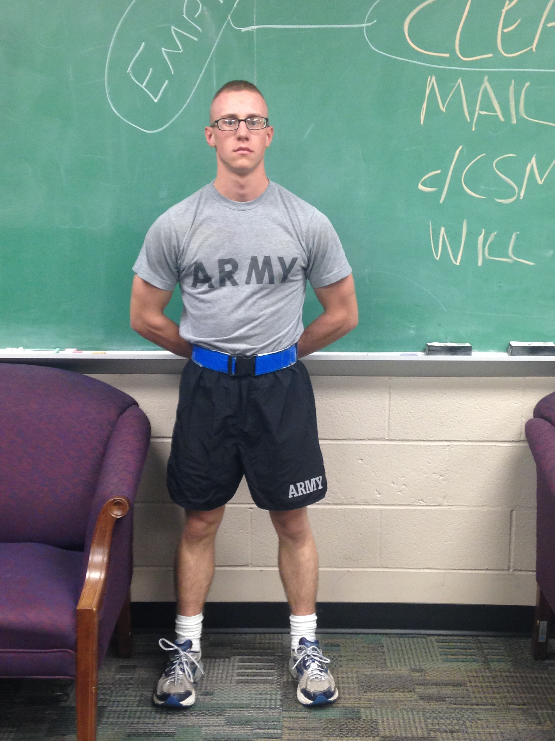 B 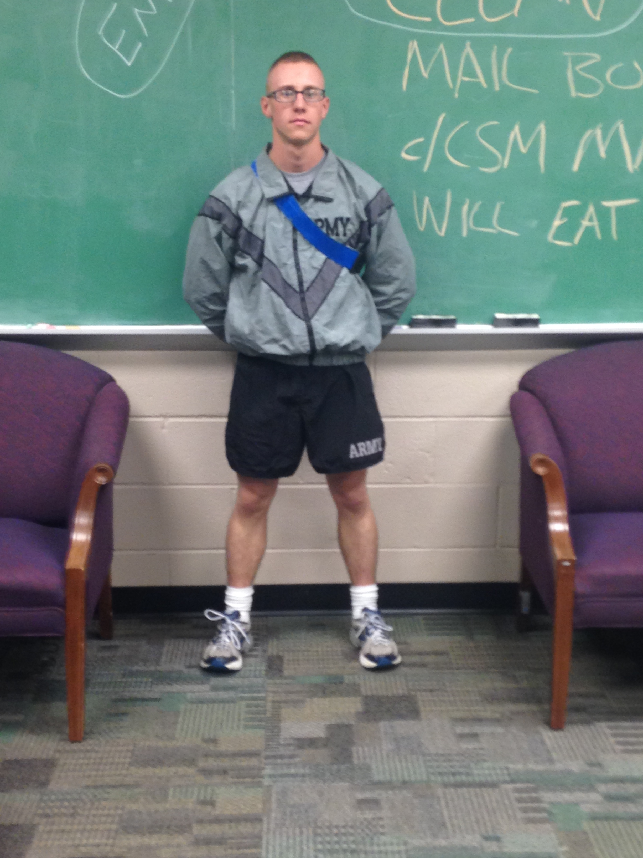

C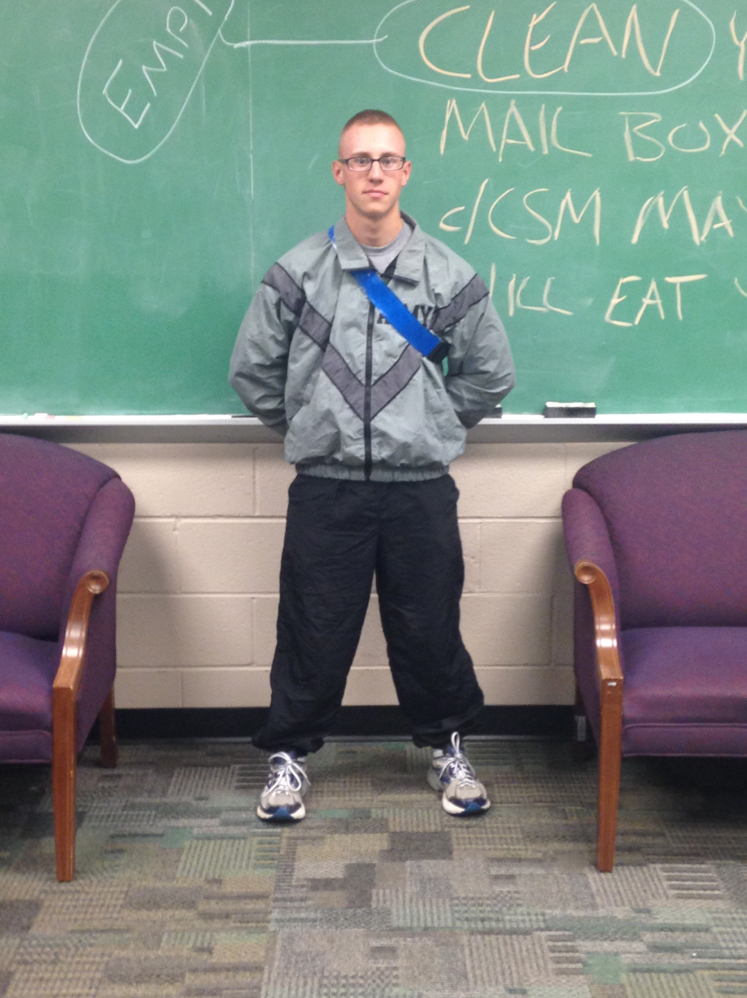 D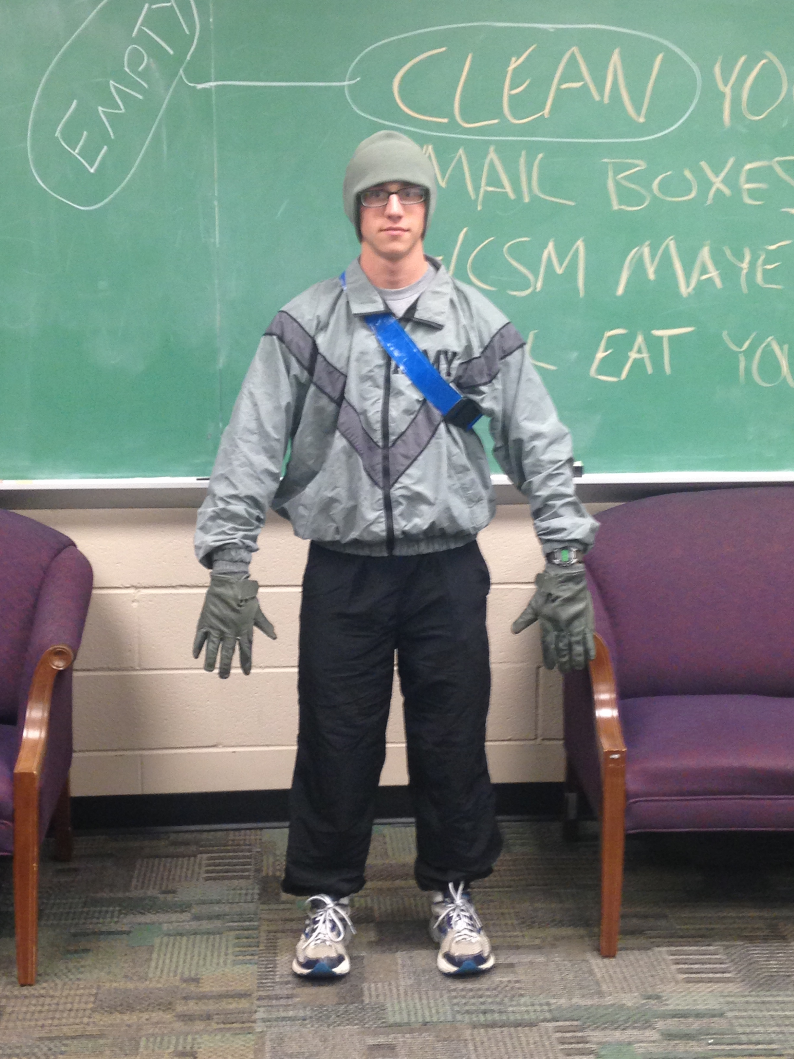

FIT:
The IPFU will not be excessively tight or baggy.
  - PT Shirt (Short Sleeve), Shorts and PT Belt around hips (warm weather)
  - PT Shirt (Short Sleeve), Shorts and Jacket w/ PT Belt across right shoulder (warm weather)
  - PT Shirt (Short Sleeve), Shorts, Jacket and Pants w/ PT Belt across right shoulder (cold weather)
  - PT Shirts (Short and Long Sleeve), Shorts, Jacket, Pants, Hat and Gloves (wool inserts and leather shells) w/ PT Belt across right shoulder (cold weather)

INSIGNIA:
The Physical Fitness Excellence Badge is authorized for wear on the short sleeved and long sleeved gray t-shirts on the upper left front side.

ARMY COMBAT UNIFORM (ACU)
The ACU will be loose fitting and comfortable; alterations to make them fit tightly are not authorized.

COMPOSITION:
Universal camouflage pixilated patterned coat, trousers, and patrol cap, tan t-shirt, green socks, tan rigger belt, and tan combat boots. Cadets may wear the black leather shell gloves with utility uniforms.

FIT:
The ACU Patrol Cap will be worn straight on the head so that the cap band creates a straight line around the head parallel to the ground. The cap will be worn so that no hair will be visible on the forehead. Subdued insignia of grade will be worn on headgear. The last name tape will be worn centered on the hook and loop pads on the back of the ACU Patrol Cap. The coat is worn hook and looped and zipped. The coat has hook and loop fasteners for wearing the U.S. flag insignia, skill tabs, shoulder sleeve insignia, shoulder sleeve insignia - former wartime service, rank, U.S. Army tape, and name tape. The coat has a zippered front closure, tilted chest pockets with hook and looped closure, hook and looped sleeve cuff closure (which must be closed at all times), integrated blouse bellows for increased upper body mobility, and shoulder pockets with hook and loop. The collar will be normally worn in the down position. Soldiers are authorized to wear the collar in the up position when wearing body armor or when weather conditions dictate the wear as prescribed by the commander. The coat is normally worn outside the trousers, and the trousers are worn with a belt. The coat will not extend below the top of the cargo pocket on the trousers and will not be higher than the bottom of the side pocket on the trousers. The elbow pouch with Hook and loop closure for internal elbow pad inserts must be closed at all times. Permanent infrared feedback squares affixed to each shoulder for nighttime identification will be covered when insignias are not worn on the pocket flaps. Sleeves will be worn down at all times, and not rolled or cuffed. The moisture wicking tan t-shirt or cotton t-shirt is worn underneath the coat and it is tucked inside the trousers at all times.
Trousers are to be fitted and worn with the trousers tucked into the top of the boots or bloused using the draw strings at the bottom of the trousers or commercial blousing devices. Personnel will not wrap the trouser leg around the leg tightly enough to present a pegged appearance or insert any items inside the trouser leg to create a round appearance at the bottom of the trouser leg. When bloused, the trousers should not extend below the third eyelet from the top of the boot. The knee Pouch with hook and loop closure for internal knee pad inserts and the bellowed calf storage pocket with hook and loop closure on the left and right legs will be worn closed at all times. The commander may require these uniforms to be pressed for special occasions when appearance should be especially sharp such as parades, reviews, inspections, or other ceremonial occasions.

INSIGNIA:
A universal camouflage Velcro tape with the inscription "U.S. ARMY" in black block letters will be worn immediately above and parallel to the top edge of the left breast pocket. The universal camouflage Velcro nametape with the individual's last name in black block letters will be worn immediately above and parallel to the top edge of right breast pocket. The Army ROTC unit Velcro patch will be worn on the left arm. The U.S. Flag will be worn on the upper right arm. Subdued insignia of grade will be worn centered on the front of the ACU patrol cap (in the horizontal position), left to right, top to bottom. Subdued insignia of grade will be worn on the chest of the coat in the vertical position.

OCCASIONS FOR WEAR:
The ACU can be worn by all cadets for leadership lab and FTXs. It is also worn by Advanced Course cadets to class on Tuesday/Thursday. The commander may authorize its wear for other occasions. All contracted Basic Course cadets are to wear their ACUs per their MSL Class Instructor’s syllabus.

Army Service Unifrom

COMPOSITION:
Blue coat, blue slacks, blue skirt (female only), long sleeved white shirt, black neck tab
(female only) or tie, black socks, oxford shoes or pumps (female only), garrison cap, black belt with brass buckle. Females may wear oxfords or pumps with either the skirt or the slacks. The commander may dictate that females wear the slacks and oxfords in order to maintain uniformity in the event of an inspection.

FIT:
Slacks will be fitted and worn so that the center of the waistband is at the natural waistline. The front crease of the slacks will reach the top of the instep and be cut on a diagonal line to reach a point approximately midway between the top of the heel and the top of the standard shoe in the back. The slacks may have a slight break in the front. The shirt will be tucked into the slacks so that the shirt edge is aligned with the front fly opening and the outside edge of the belt buckle forms a straight" gig line." Skirts will not be more than 1 inch above or 2 inches below the crease in the back of the knee. The long sleeved shirt will extend to the center of the wrist bone. The coat will extend one inch below the wrist bone.

INSIGNIA:
The nameplate will be a black laminated plastic plate, 1 inch by 3 inches by 1/16 inch thick, with a white border not to exceed 1/32 inch in width. Lettering will be block type, indented white lettering, 3/8 inch in height and centered on the plate. Only last names will be used. The finish may be either gloss or matte. Male Cadets will center the nameplate on the flap of the right pocket, centered between the top of the button and the top of the pocket. Female cadets will wear the nameplate one to two inches above the top button, centered horizontally on the wearer's right side. Ribbons will be worn centered 1/8 inch above the left breast pocket with 1/8 inch between each row of ribbons. Basic Course cadets will wear the Torch of Knowledge disc approximately one inch above the notched seam, centered on both collars with the center line parallel to the inside edge of the lapel. Advanced Course cadets will wear the ROTC insignia in the same position. The Bulldog Battalion shoulder insignia is centered 1/2 inch below the seam of the right sleeve. The Leadership Excellence patch is centered 1/2 inch below the seam of the left sleeve. The
DUI will be centered on the shoulder loops between the rank and the outside edge of the button with the base of the insignia pointed toward the rank. Cadets in the grade of cadet private first class and below will wear non subdued insignia of grade centered on the collar of the white shirt with the insignia bisecting the points of the collar and the bottom of the insignia positioned one inch from the collar point. Cadet noncommissioned officers will not wear rank on their Army Service Uniform. Cadet Officers will wear their rank on the shoulder loops but specific placement varies. Consult CC Reg 670-1 for specific guidance.

OCCASIONS FOR WEAR:
The Army Service Uniform (ASU) will be worn by members of the Color Guard, while participating in formal inspections, when escorting distinguished visitors, and when appearing before a board. The commander may authorize its wear for other occasions.

