Cadet Organizations

Ranger Challenge Team
The Ranger Challenge Team competes in what amounts to the varsity sport of ROTC. It is the most competitive and challenging event of the year. Nine-member teams train intensively in physical fitness, orienteering, military patrolling, and river crossing operations. The team is open to males and females of all MSL levels. Practice begins in the fall and the competition is held each October against schools from Missouri, Arkansas, Illinois, Tennessee and Kansas.

Buddy Challenge Team
The Buddy Challenge Team Competition is an elite annual event held in April, where two member cadet teams compete against the best within their respective ROTC regions. It utilizes the skills acquired from Ranger Challenge and demands extreme physical and mental conditioning.

Color Guard
The Color Guard posts the US and Missouri flags at all home football games. Additionally, Color Guard is responsible for posting the colors at all major ROTC functions such as the Cadet Awards Ceremony and the Veterans Day Ceremony.

RECONDO Club
The RECONDO Club strives to better cadets by conducting in-depth courses on military tactics every week, conducting squad training exercises five times per semester and enforcing military conduct codes and standards. RECONDO strives to better prepare cadets to lead as future officers in the United States Army.

Mentor Program
The cadet Mentor Program is designed to ensure new cadets are fully assimilated into the Bulldog BN. MS IIIs and MSIVs are mentors and are responsible for "showing the ropes" to MSL I and MSL II cadets as well as high school seniors considering our program.

Bataan Memorial Death March
The Bataan Memorial Death March is a challenging march through the high desert terrain of White Sands Missile Range, N.M., conducted in honor of the heroic service members who defended the Philippine Islands during World War II. Participants train to compete in a 26.2 mile challenging route in heavy or light divisions.

German Proficiency Badge
The GPB is a foreign medal that is authorized to be worn in the United States Army. The competition includes a long distance run, 100m run, various track and field events, swim, pistol shoot, first aid test, and ruck march. Participants qualify for bronze, silver, or gold medals.

Leadership Development Program (LDP)

Leadership is influencing people – by providing purpose, direction, and motivation – while operating to accomplish the mission and improving the organization. (FM 6-22)

The Leadership Development Program is used as an evaluation tool for all ROTC Cadets. Throughout their ROTC experience, Cadets are given leadership positions. These positions include Platoon Leader, Squad Leader, Team Leader, etc… For each of these positions, an MS IV cadet evaluates the leader in position. The LDP is also used at LDAC and cadets are evaluated by TAC Officers and NCOs. The LDP evaluates the cadet leader based on Leadership Attributes and core Leadership Competencies:

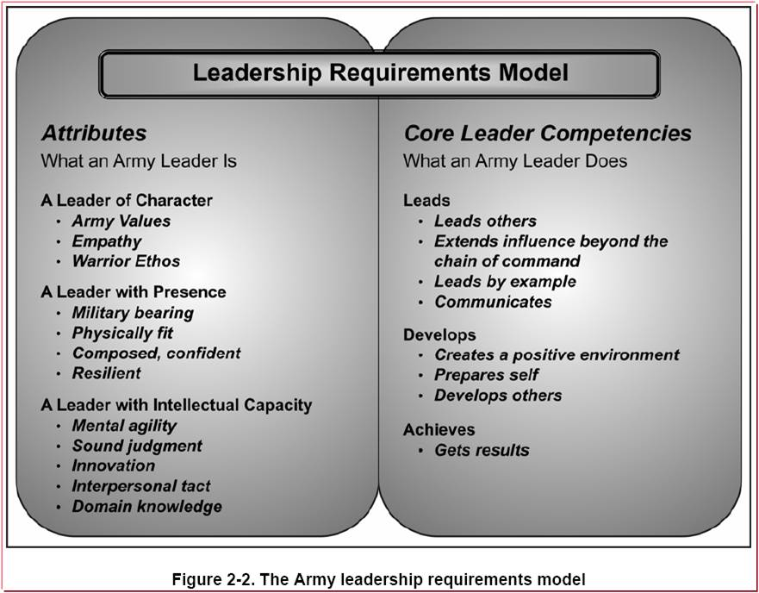

DO

KNOW
BE

ARMY VALUES:

Loyalty (LO) Faithfully supporting family / friends, country/team
Respects the constitution and laws
Has basic understanding of obligations to country/Army/self
Observes higher HQ priorities
Works within the system; does not try to manipulate the system to own advantage
Duty (DU) – Professional work ethic
Carries out requirements of job, tasks, or mission
Consistently performs to standard
Complies with policies and directives
Aware of and performs to professional standards
Respect (RE) – Treating others with dignity
Considerate in offering criticism
Deals with others fairly
Frequently listens supportively
Usually discreet and tactful
Basically concerned about others; makes some checks
Gets along with peers
Selfless Service (SS) – Placing personal interests aside
Perseveres despite hardship; does not shy away
Balances mission and personal needs
Able to balance needs and priorities
Willing to assist others in completion of mission
Works toward pursuing excellence
Honor (HO) – Compelled by strong sense of right
Has a clear sense of the public code of professional Army Values
Lives within the code of professional Army values
Does not lie, cheat or steal, nor tolerate those things in others
Integrity (IT) – Reliable and trustworthy
Shows good moral judgment and behavior
Abides by basic moral principles
Personal Courage (PC) - Overcoming physical and mental fears
Perseveres in face of adversity
Adequately copes with stress and fears
Responsible for own decisions/actions
Accepts responsibility for mistakes

Empathy (EP) – Propensity to share experiences seeing something from another person’s point of view. Identifying with and entering into another person’s feelings and emotions.
Warrior Ethos (WE) Professional attitudes and beliefs

“I will always place the mission first
I will never accept defeat
I will never quit
I will never leave a fallen comrade”

Presence:
Military Bearing (MB) – Projecting a commanding presence and professionalism
Physically Fit (PF) – having sound health, strength and endurance
Mental Agility (MA) –Flexibility of mind, anticipate or adapt
Resilient (RS) –Recover quickly while maintaining mission and organization focus

Intellectual Capacity:
Mental Agility (MA) – Flexibility of mind, anticipate, adapt
Sound Judgment (SJ) - Capacity to assess situations and draw feasible conclusions
Innovation (IN) – Ability to introduce something new
Interpersonal Tact (IP) – Effectively interact with others
Domain Knowledge (DK) – Possessing facts, beliefs and logical assumptions

Leads:
Leads Others (LD) – Influencing Soldiers or Army Civilians in the unit or organization.
Extends Influence beyond CoC (EI) – Ability to operate in an environment encompassing higher and lower command structures.
Leads by Example (LE) – Providing an example that others consider and use what they do.
Communicates (CO) – Attain a clear understanding of what needs to be done and why
Develops:
Creates a Positive Environment (CP) – Creates a positive cultural and ethical climate.
Prepares Self (PS) – Self study, self development and becoming multi-skilled.
Develops Others (DO) – Growing others into competent and confident leaders.
Achieves:
Get Results (GR) – Developing and executing plans while providing direction, guidance and clear priorities to guide others toward mission accomplishment.

CADET LEADERSHIP TRAINING (CLT)

Leader Development & Assessment Course (LDAC)

Leader Development and Assessment Course (LDAC) is the most important training event for an Army ROTC cadet or National Guard Officer Candidate. The 32-day course incorporates a wide range of subjects designed to develop and evaluate leadership ability. The challenges are rigorous and demanding, both mentally and physically. LDAC tests intelligence, common sense, ingenuity and stamina. These challenges provide a new perspective on an individual's ability to perform exacting tasks and to make difficult decisions in demanding situations.
The course places each cadet and officer candidate in a variety of leadership positions, many of which simulate stressful combat situations. In each position, cadets are evaluated by platoon tactical and counseling (TAC) officers and noncommissioned officers. In addition to proving their leadership ability, cadets and officer candidates must meet established standards in physical fitness, weapons training, communication, combat patrols and demonstrate their proficiency in many other military skills. Cadets and officer candidates must pass all camp events satisfactorily to be considered competitive for a commission as an Army officer. The following events are standard at LDAC:

Field Leaders Reaction Course
FLRC is designed to develop and evaluate leadership and to build teamwork early in the camp cycle. Course administration is accomplished using the established cadet organization and chain of command. Cadet leadership potential is assessed by committee evaluators. Cadets are provided the opportunity to get early feedback on their leadership strengths, weaknesses, styles and techniques.

Basic Rifle Marksmanship
Future Army Leaders must know the characteristics of the basic Army rifle, how to fire it accurately, and how to employ it in combat. Rifle marksmanship training teaches cadets to engage and hit targets on the battlefield. Cadets are required to fire for record. Qualification is a camp completion criterion.

Advanced Weapons
Squad Automatic Weapon / M60 machine gun training teaches cadets the characteristics, functions and employment of the weapons. This training provides skills used in later tactical phases of camp.

Land Navigation
Land navigation training must be mastered early in the camp cycle for the cadets to be fully successful in the tactical training which follows. The land navigation evaluation consists of three portions totaling 100 points. The written examination is worth 30 percent. The day land navigation test is worth 50 percent. Night land navigation is worth 20 percent. Each cadet must earn 70 percent on each test to pass this event. A passing score in land navigation is a camp completion criterion.

Individual Tactic Training (ITT)
ITT is the first block of instruction in tactics at National Advanced Leadership Camp. It covers individual battlefield skills, combat movement techniques, and procedures necessary for subsequent tactical training at the squad and platoon level.

Fire Support
Fire Support teaches cadets the importance and lethality of artillery fire on the battlefield, employment of indirect fires, and gives them the opportunity to perform the duties of howitzer crewmen.

Hand Grenades
Basic understanding and use of hand grenades is an important facet of weapons and tactical training. Cadets learn to identify major types of grenades. They learn the grenades' characteristics and uses. Cadets also employ live grenades.

Nuclear, Biological, Chemical
NBC training provides basic soldier skills that cadets must master to meet pre-commissioning requirements. Cadets learn characteristics, maintenance and employment of NBC equipment. They also develop confidence in defensive equipment during mask confidence exercises.

Squad Situational Training Exercises
Squad STX is a five-day, two-phase event. The first two days, the Squad training phase, are designed to train squad battle drills and collective tasks. The last three days, the Squad STX lane phase, are designed to evaluate leadership using tactical scenarios. Each cadet receives two formal evaluations of their performance as a squad leader during this phase. Squad operations build on and reinforce all previous instruction. Cadets use knowledge of land navigation, terrain association, weapons systems, and all individual training previously presented.

Patrolling Situational Training Exercises
Patrolling STX is a three-day event that provides cadets practical experience leading soldiers at the section level. The first day is a training day on which cadets are taught the fundamentals of patrolling missions. The following two days are designed to evaluate leadership potential using tactical scenarios by giving cadets opportunities to utilize the training as patrol leaders and assistant patrol leaders. Patrolling STX builds on and reinforces all previous instruction, and teaches cadets the basics of air assault operations. This event culminates cadets' training at National Advanced Leadership Camp.

Cadet Troop Leadership Training & Internships

Cadet Troop Leadership Training:
The CTLT track provides Cadets the opportunity to experience leadership in Army Table of Organization and equipment (TO&E) units over a three to four week period. Cadets serve in platoon leader positions or other positions where a second lieutenant is normally assigned. Platoon Leader positions have 3-4 week duration depending on the hosting unit and location. Assignments include units that are located CONUS and OCONUS. Cadets are assigned a unit mentor, and are provided on-post lodging and meals via a Dining Facility. This program is exclusively designed for MSIII Cadets after completion of LDAC. There are no exceptions to this policy.

Drill Cadet Leadership Training:
The 4-week DCLT program provides Cadets serve in a platoon leader or executive officer positions in IMT companies and work closely with Drill Sergeants and other cadre.
Cadets experience leadership training with Initial Military Training (IMT) Companies.
Positions lengths vary in duration depending on the host unit and location. Cadets have the opportunity to apply leadership skills, interact with highly skilled and experienced Noncommissioned Officers (NCOs) and drill sergeants. DCLT improves common task skill proficiency in an Army training environment. Cadets must attend a Staff Cadre Training Course (SCTC) prior to training in IMT units .This program is exclusively designed for MSIII Cadets after completion of LDAC.

Internships:
The internship track offers a myriad of opportunities for Cadets who seek additional training in specialized areas such as scientific application, engineering, nursing, medicine, intelligence, cultural awareness, and language proficiency. The internship types, locations, and allocations change significantly from year to year. Cadet Command is significantly increasing overseas opportunities focused on cultural awareness and language proficiency. These programs are meant primarily for MSII and MSIII Cadets. Select the Internship link to see more information on each program. In some cases an MSI Cadet can request an exception to this policy.

Nurse Summer Training Program (NSTP – Required for Nursing Majors):
Cadets with an Academic Major of Nursing are the only cadets eligible to apply for this program. Cadets are assigned to Army Medical Facilities both in the continental United States (CONUS) and outside the continental United States (OCONUS) including Europe and Asia. NSTP provides nursing cadets with opportunities to develop and practice leadership in a clinical environment. Cadets work side-by-side with an Army Nurse Corps Officer preceptor. To qualify, cadets must submit an application packet through their PMS and the Brigade Nurse counselor to the Cadet Command Chief Nurse. Cadets applying for this program must be certified in Basic Cardiac Life Support (BCLS) and certification may not expire prior to the completion of NSTP training.

Cadet Practical Field Training (CPFT)

CPFT involves training at different Army schools. Generally, in a typical year, the total number of CPFT allocations equals approximately ten percent of the cadet population at large. Battalion commanders will prepare, select and send to CPFT only those with the highest potential for completing the CPFT training and for being commissioned. Cadet Command pays for travel. Billeting and mess are provided by the installation in most cases. All cadets must meet the eligibility criteria to be selected. The following are CPFT schools available:

Air Assault School:
Army Air Assault School is a two week course conducted at Fort Campbell, Kentucky. This school is designed to make soldiers qualified to conduct airborne helicopter operations. Air Assault is a fast-paced exercise in mental alertness and physical endurance and upon completion; cadets are awarded the Air Assault Badge.

Airborne School:
Airborne school is a three-week course conducted at Fort Benning, Georgia. Cadets in good physical condition may compete for a school allocation. At airborne, cadets train with regular Army officers and enlisted men and women. Upon completion of the course, cadets earn their jump wings and are parachutist qualified.

Northern Warfare School:
Northern Warfare School is a two-week course located in Fort Greely, Alaska. Students are taught survival techniques in northern climates as well as basic skills of military mountaineering. Subjects include rock and ice climbing, cold weather survival, rappelling, and inland waterway operations.

Mountain Warfare School:
Mountain Warfare School is a two-week course located in Jericho, Vermont. Training is designed to improve cadet mountain operations and requires top-notch physical conditions. This course focuses on combat arms and is not taught in a garrison environment.

Cadet Field Training (CFT):
CFT is a 4-week program of instruction that provides training and instruction in the following areas:
- Military Training, both individual (rifle marksmanship, communications and combat skills) and collective (patrolling, convoy, QRF, Cordon and Search)
- Physical Training
- Professional Development (honor instruction, leadership)
CFT supports Cadet Leader Development System by maximizing opportunities for upper-class Cadets to exercise Troop Leading Procedures in a tactical environment, by stressing the tactical and ethical decision making process in a time constrained environment.

