APPENDIX K
Drill and Ceremonies

POSITION OF ATTENTION
Two commands can be used to put personnel at the Position of Attention:
• FALL IN is used to assemble a formation or return it to its original configuration.
• The two-part command for Attention is used for soldiers at a rest position. Assume the Position of Attention on the command FALL IN or the command Squad (Platoon), ATTENTION.
a. To assume this position, bring the heels together sharply on line, with the toes pointing out equally, forming a 45-degree angle. Rest the weight of the body evenly on the heels and balls of both feet. Keep the legs straight without locking the knees. Hold the body erect with the hips level, chest lifted and arched, and the shoulders square.
b. Keep the head erect and face straight to the front with the chin drawn in so that alignment of the head and neck is vertical.
c. Let the arms hang straight without stiffness. Curl the fingers so that the tips of the thumbs are alongside and touching the first joint of the forefingers. Keep the thumbs straight along the seams of the trouser leg with the first joint of the fingers touching the trousers.
d. Remain silent and do not move unless otherwise directed.

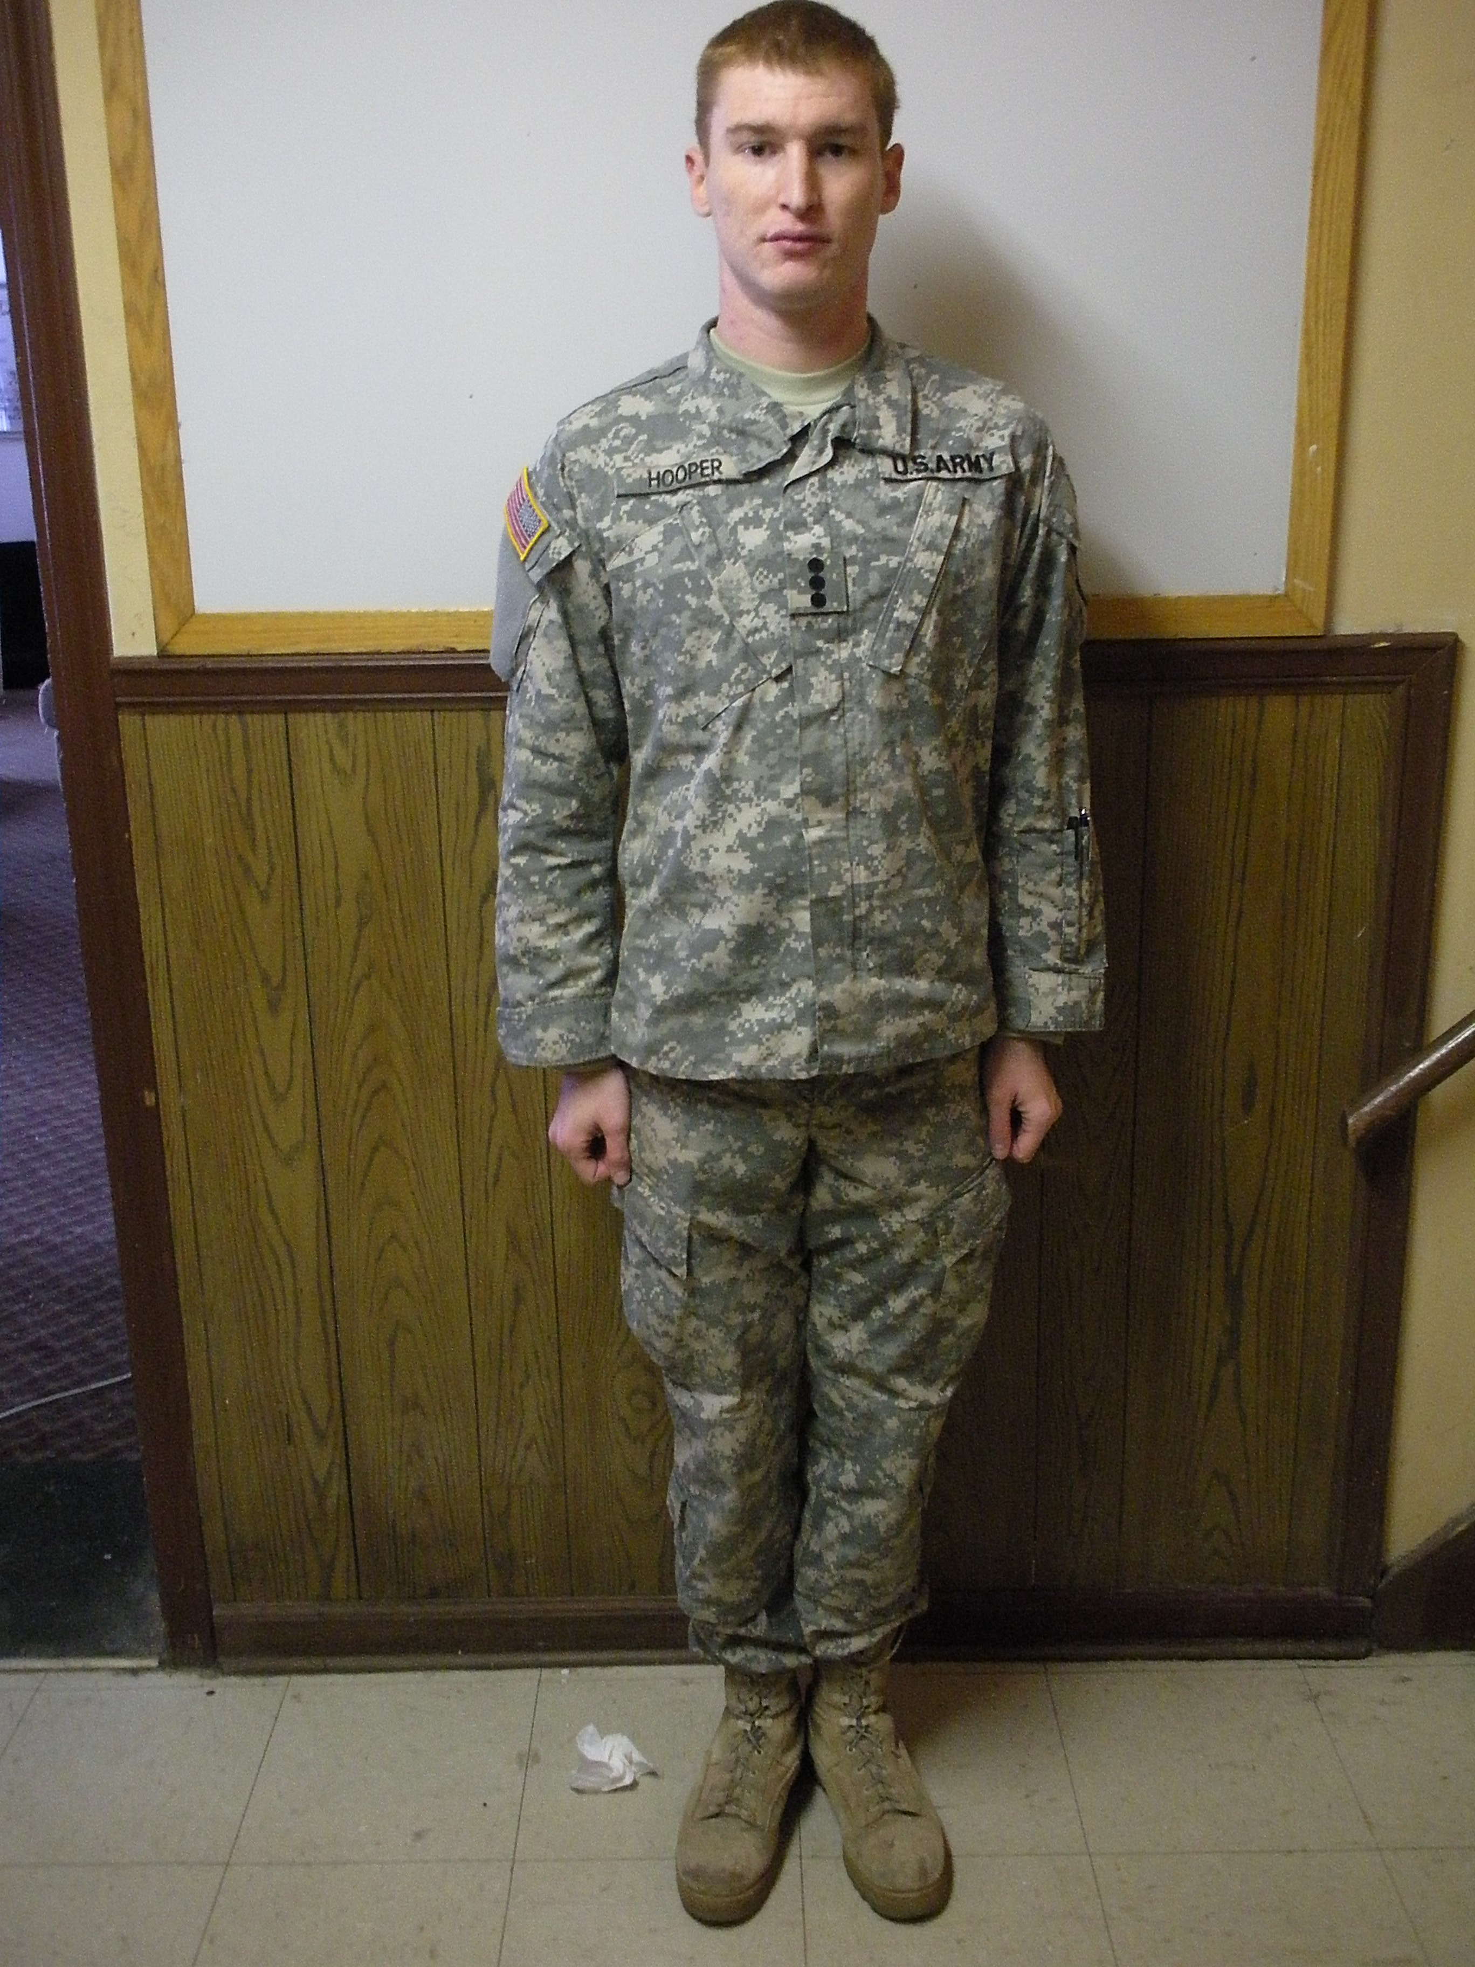
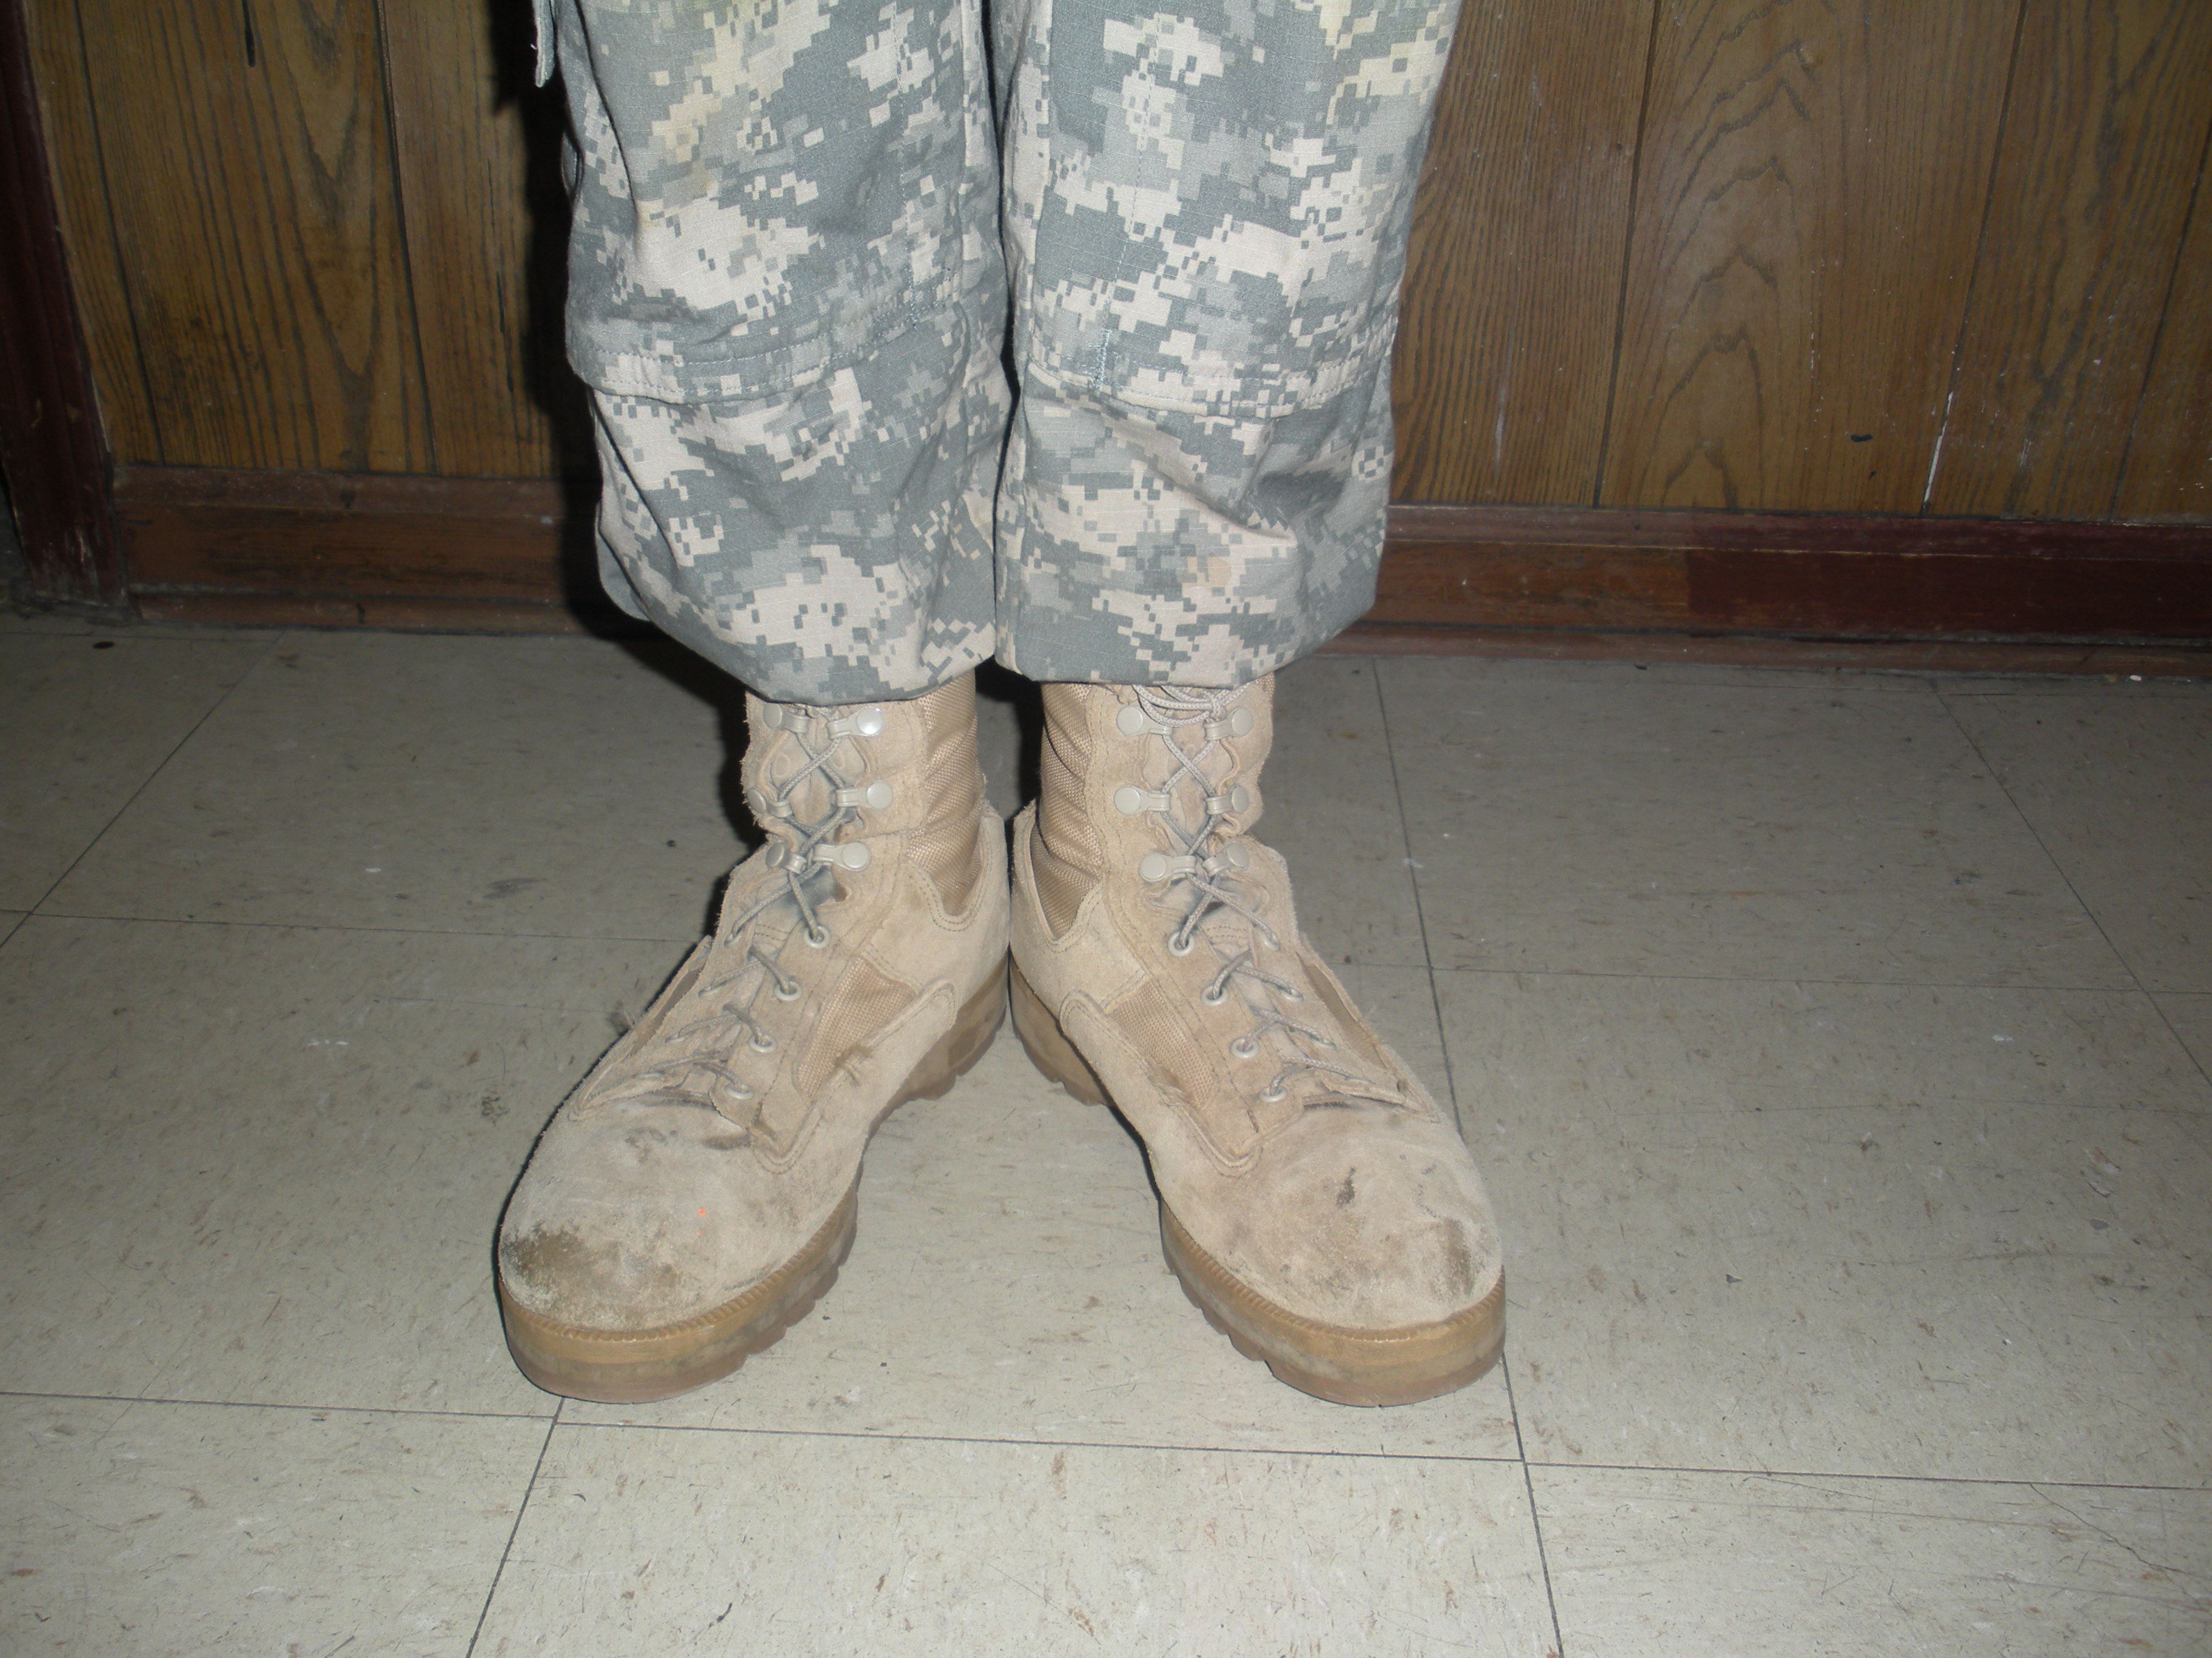

REST POSITIONS AT THE HALT Any of the positions of rest may be commanded and executed from the Position of Attention.

a. PARADE REST: Parade Rest is commanded only from the Position of Attention. The command for this movement is Parade, REST.
(1) On the command of execution REST, move the left foot about 10 inches to the left of the right foot. Keep the legs straight without locking the knees, resting the weight of the body equally on the heels and balls of the feet.
(2) Simultaneously, place the hands at the small of the back and centered on the belt. Keep the fingers of both hands extended and joined, interlocking the thumbs so that the palm of the right hand is outward.
(3) Keep the head and eyes as in the Position of Attention. Remain silent and do not move unless otherwise directed. Stand at Ease, At Ease, and Rest may be executed from this position.

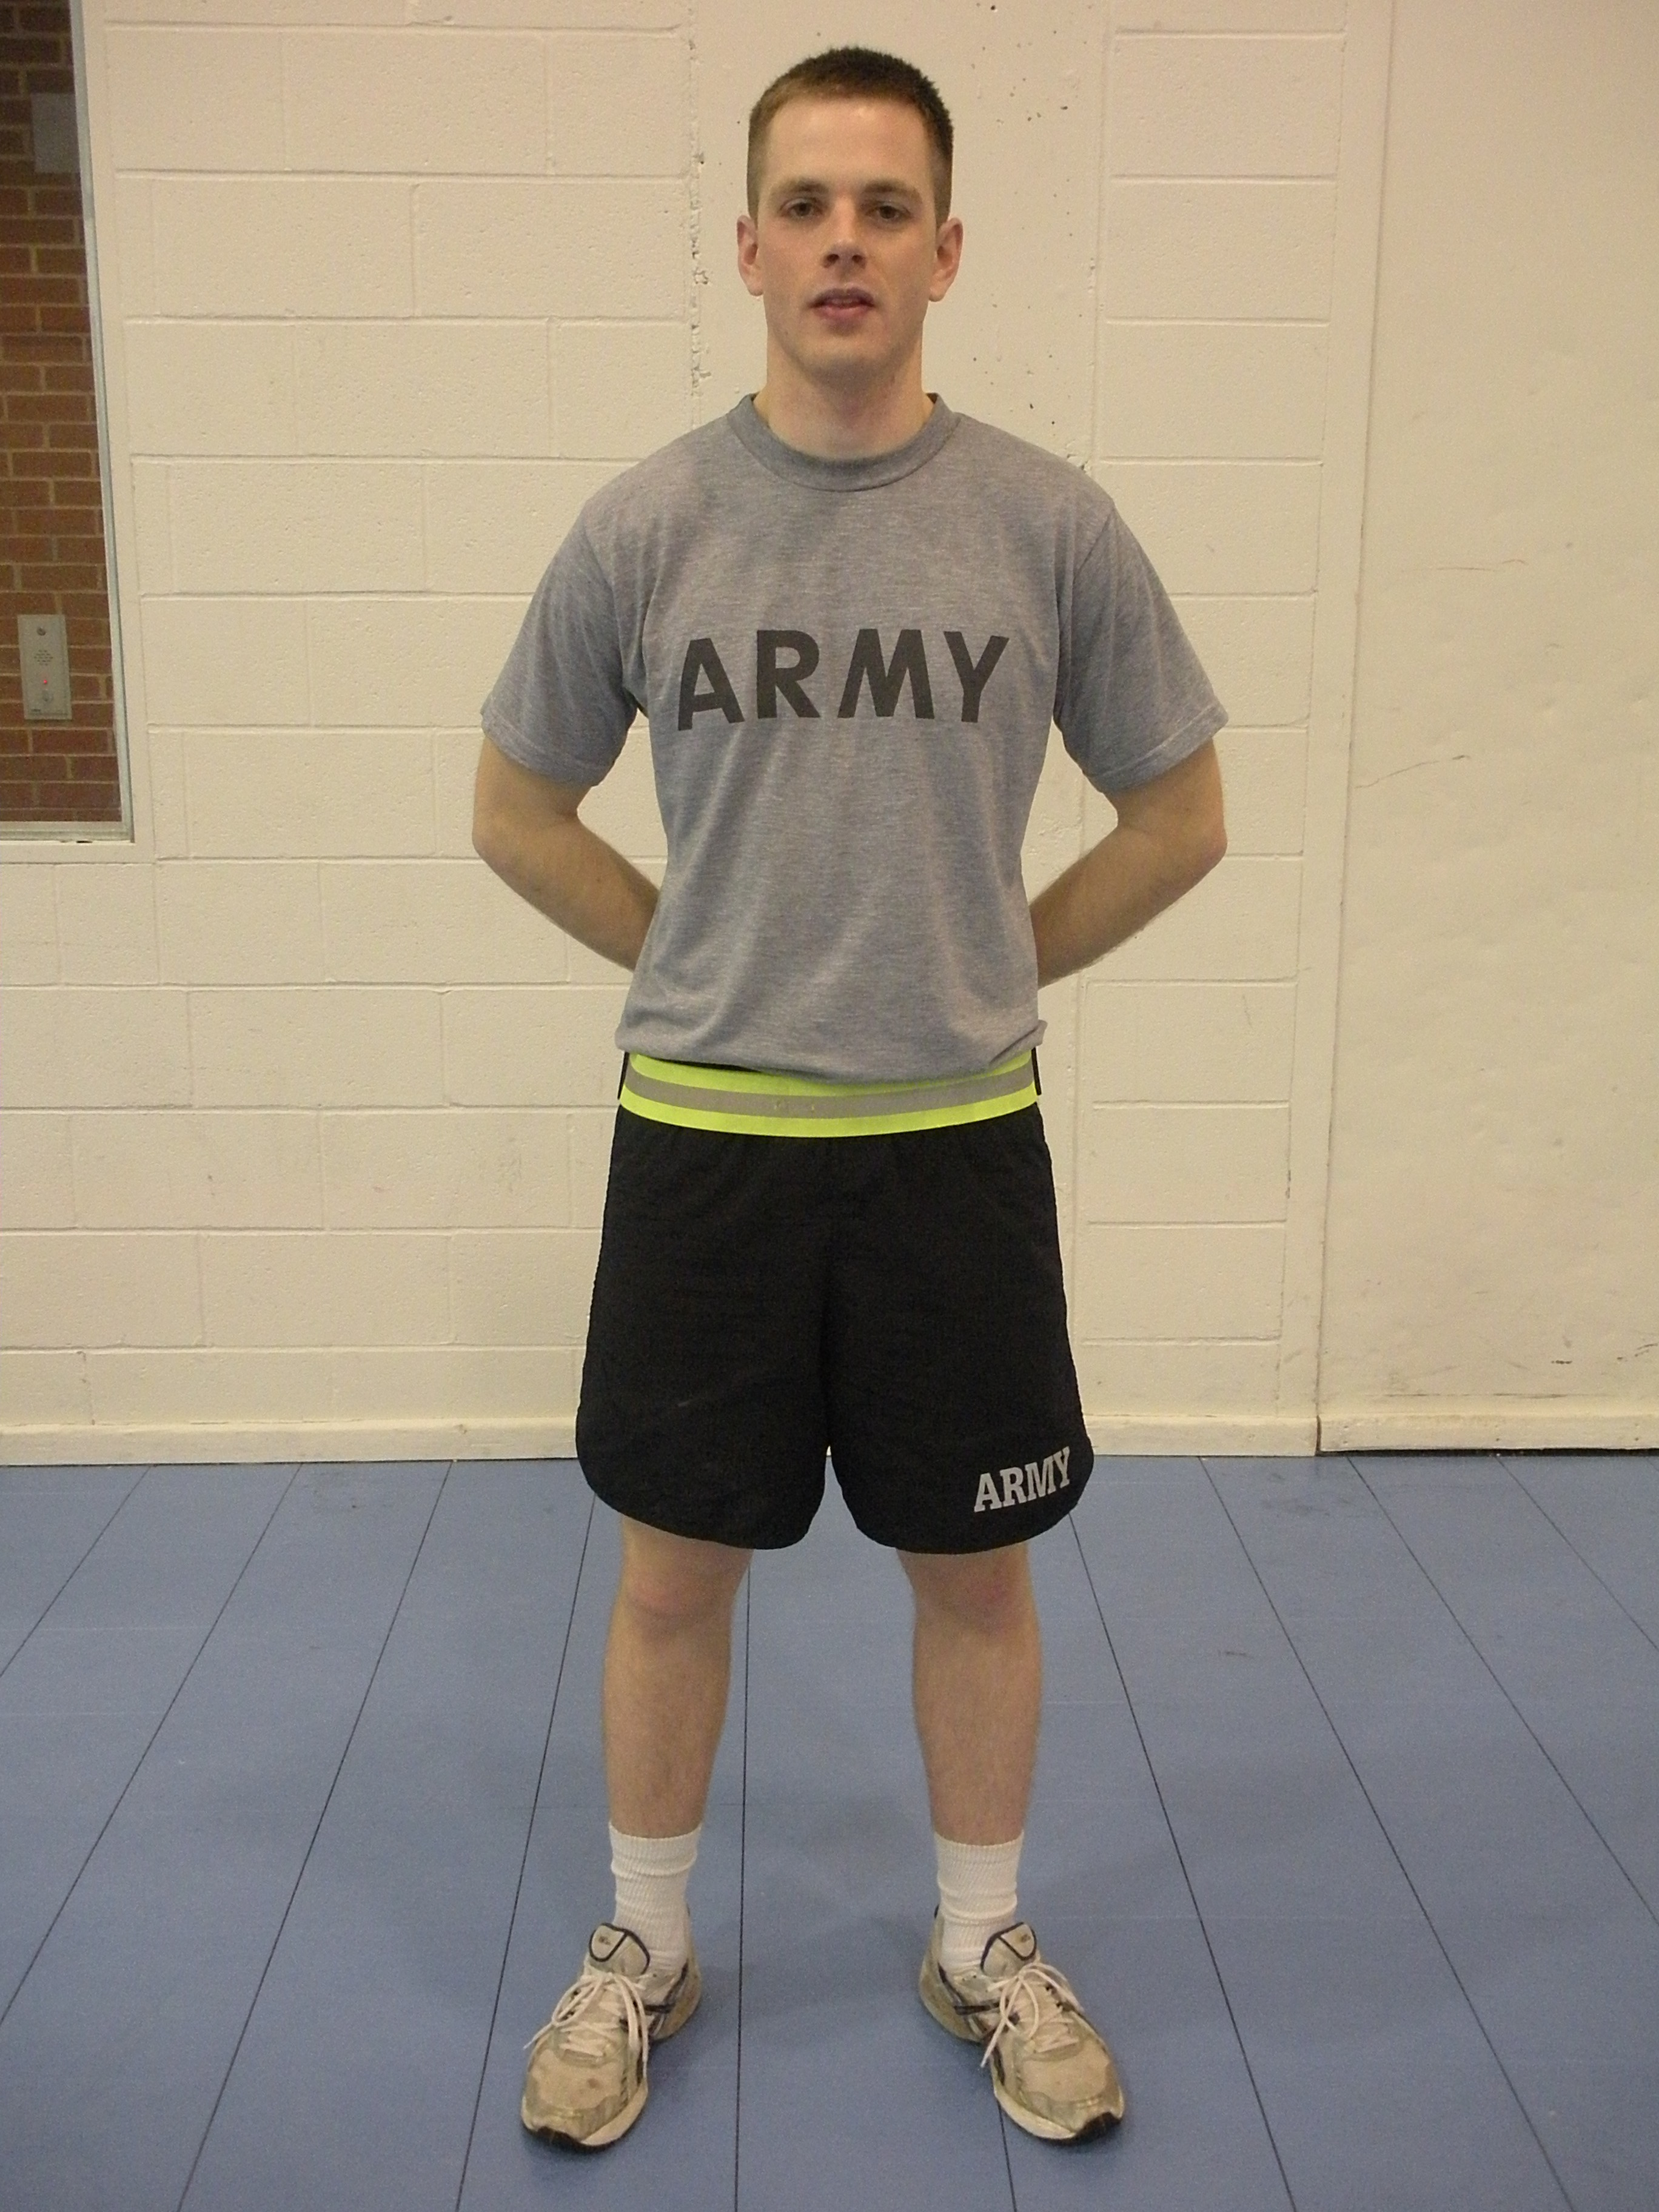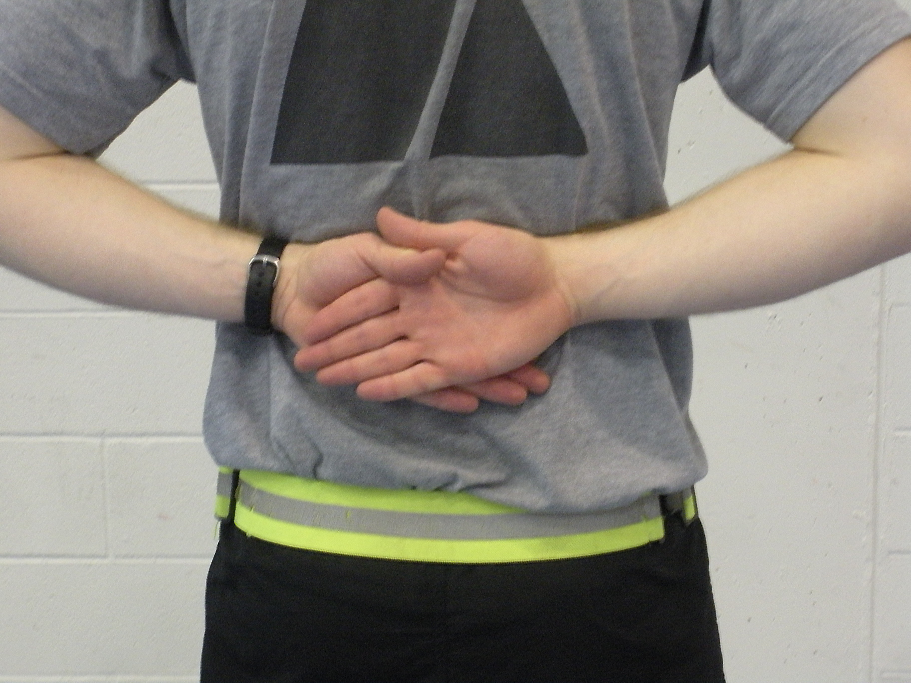

b. STAND AT EASE: The command for this movement is Stand at, EASE. On the command of execution EASE, execute Parade Rest, but turn the head and eyes directly toward the person in charge of the formation. At Ease or Rest may be executed from this position.

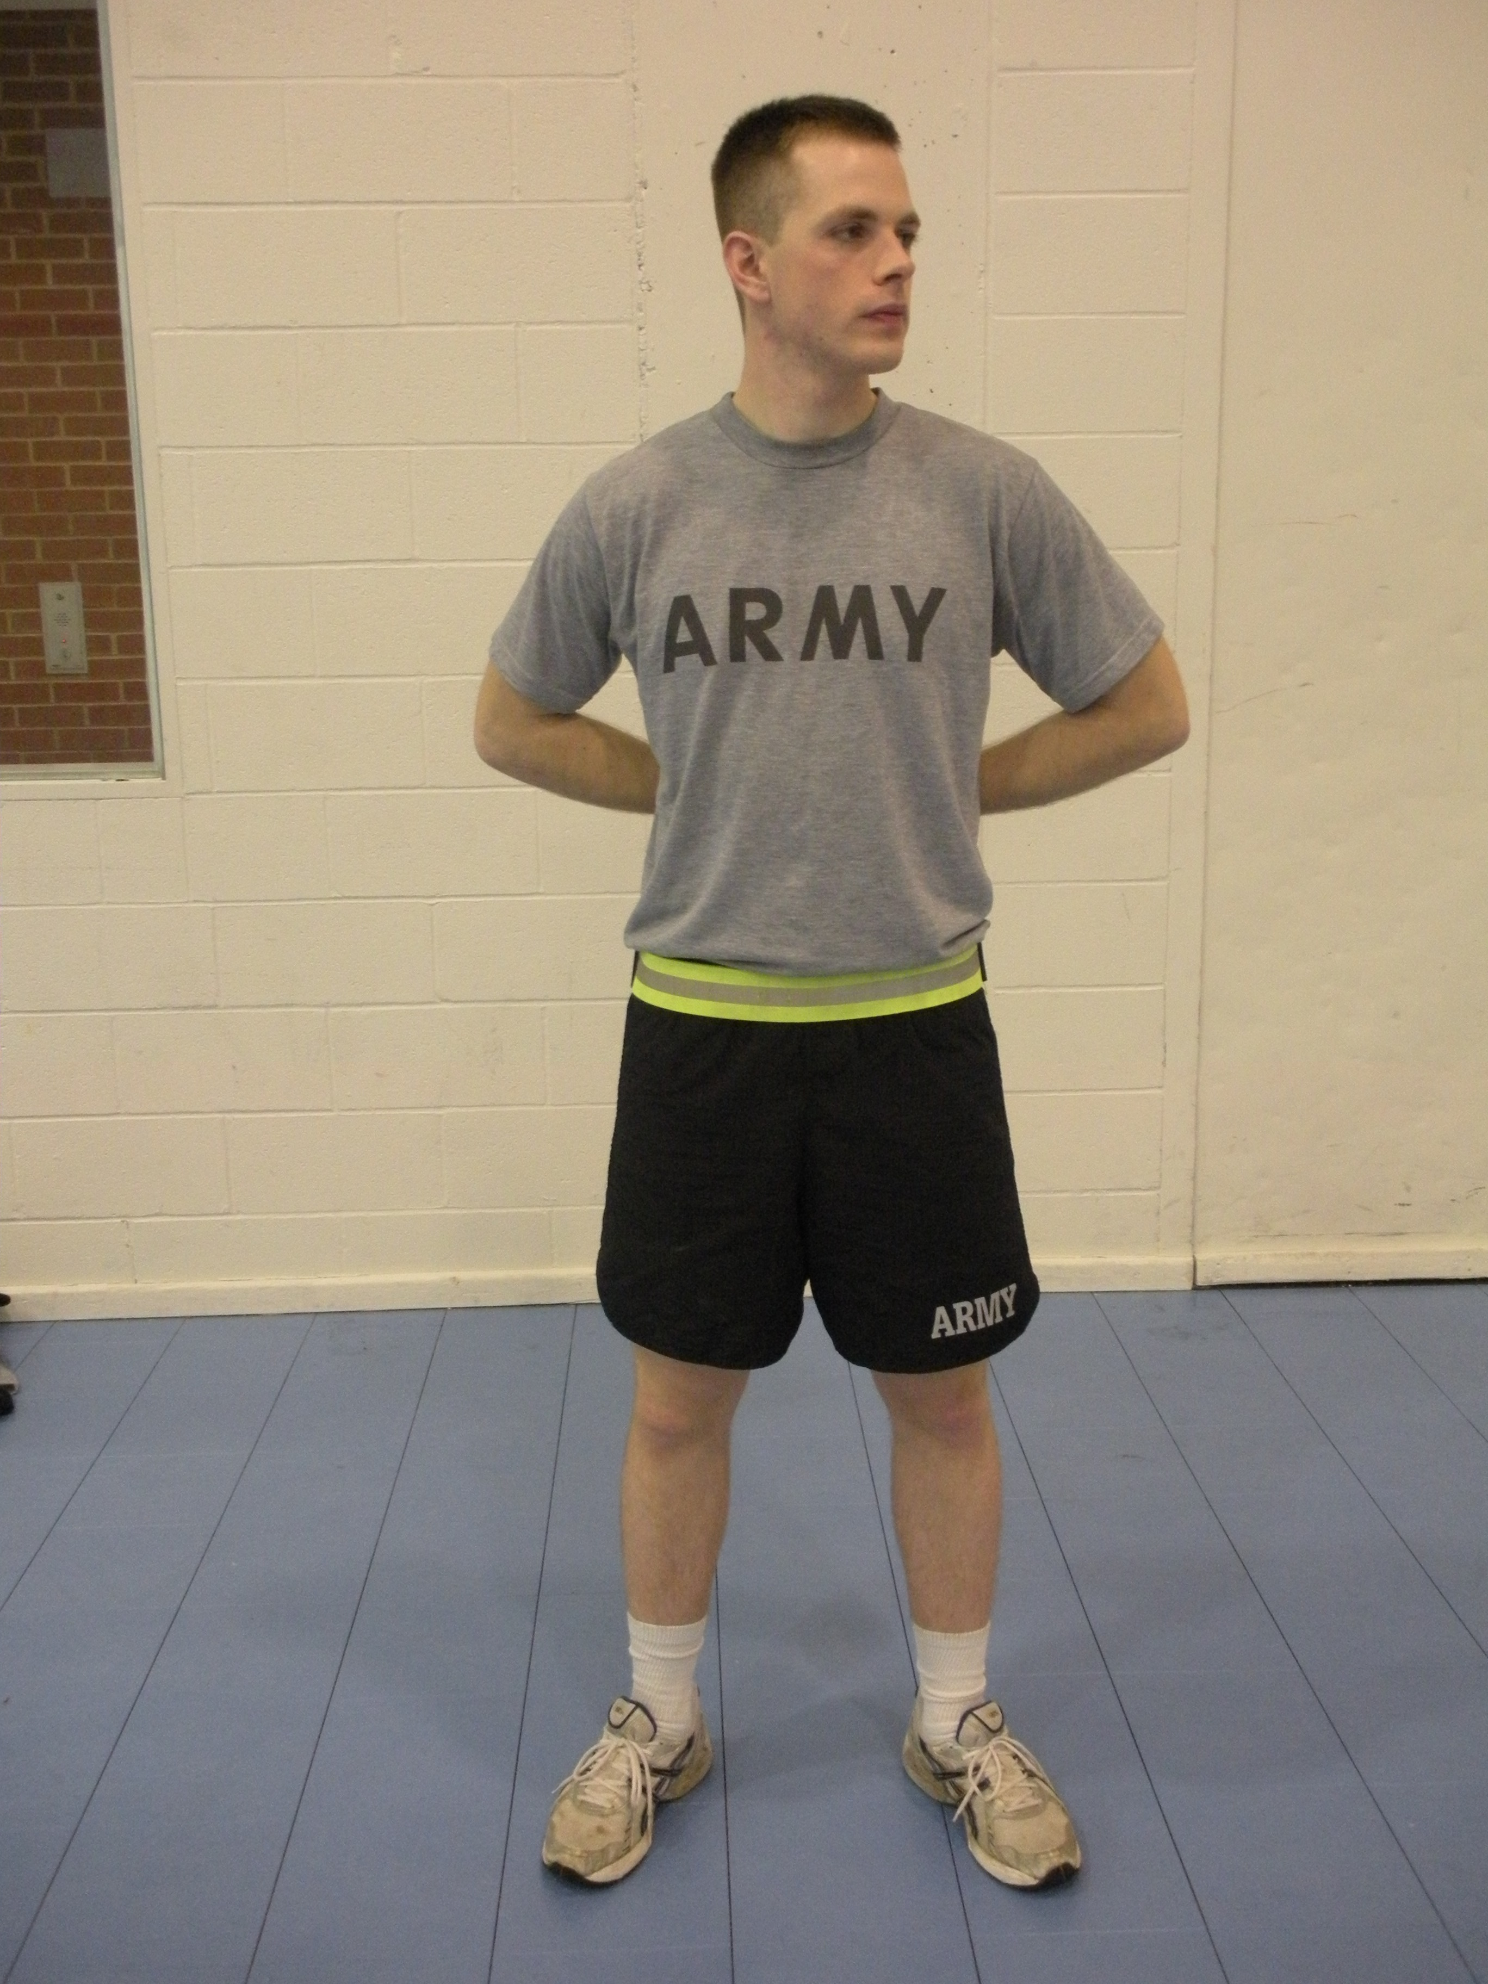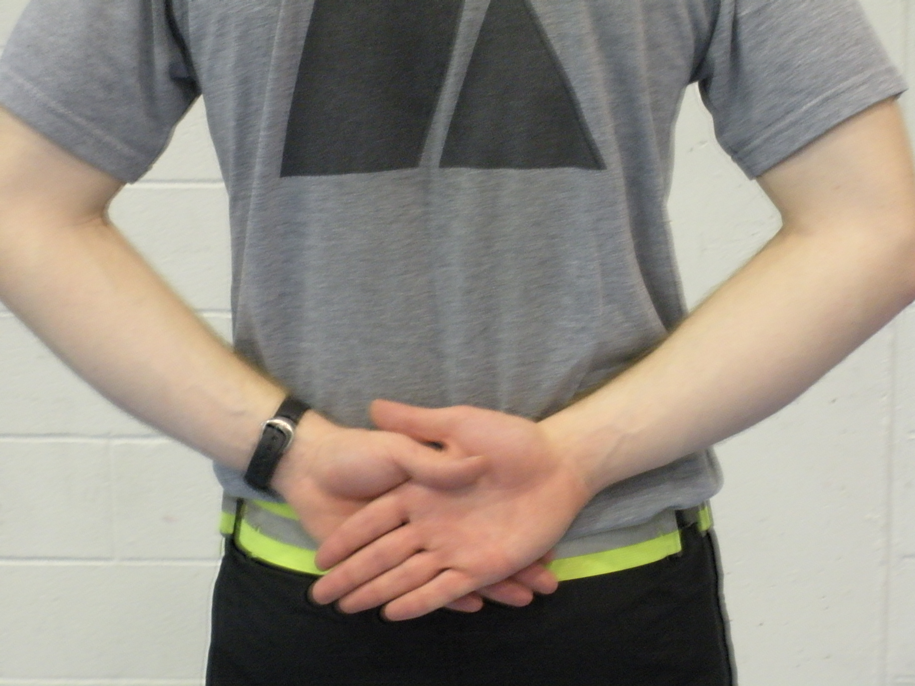

c. AT EASE: The command for this movement is AT EASE. On the command AT EASE, the soldier may move; however, he must remain standing and silent with his right foot in place. The soldier may relax his arms with the thumbs interlaced. Rest may be executed from this position.

d. REST: The command for this movement is REST. On the command REST, the soldier may move, talk, smoke, or drink unless otherwise directed. He must remain standing with his right foot in place. AT EASE must be executed from this position to allow soldiers to secure canteens, other equipment, and so forth.

NOTE: On the preparatory command for Attention, immediately assume Parade Rest when at the position of Stand at Ease, At Ease, or Rest. If, for some reason, a subordinate element is already at attention, the members of the element remain so and do not execute parade rest on the preparatory command, nor does the subordinate leader give a supplementary command.

FACING AT THE HALT
a. Left (Right) FACE: The command is Left (Right), FACE.
(1) On the command of execution FACE, slightly raise the right heel and left toe, and turn 90 degrees to the left on the left heel, assisted by a slight pressure on the ball of the right foot. Keep the left leg straight without stiffness and allow the right leg to bend naturally.
(2) On count two, place the right foot beside the left foot, resuming the Position of Attention. Arms remain at the sides, as in the Position of Attention, throughout this movement

NOTE: Instructions are for a Left, FACE. Turn the other direction for a Right, FACE.

b. About, FACE:
- (1) On the command of execution FACE, move the toe of the right foot to a point touching the marching surface about half the length of the foot to the rear and slightly to the left of the left heel. Rest most of the weight of the body on the heel of the left foot and allow the right knee to bend naturally.
(2) On count two, turn to the right 180 degrees on the left heel and ball of the right foot, resuming the Position of Attention. Arms remain at the sides, as in the Position of Attention, throughout this movement.

THE HAND SALUTE
The Hand Salute is a one-count movement. The command is Present, ARMS. The Hand Salute may be executed while marching. When marching, only the soldier in charge of the formation salutes and acknowledges salutes. When double-timing, an individual soldier must come to Quick Time before saluting.
a. When wearing headgear with a visor (with or without glasses), on the command of execution ARMS, raise the right hand sharply, fingers and thumb extended and joined, palm facing down, and place the tip of the right forefinger on the rim of the visor slightly to the right of the right eye. The outer edge of the hand is barely canted downward so that neither the back of the hand nor the palm is clearly visible from the front. The hand and wrist are straight, the elbow inclined slightly forward, and the upper arm horizontal.
b. When wearing headgear without a visor (or uncovered) and not wearing glasses, execute the Hand Salute in the same manner as previously described, except touch the tip of the right forefinger to the forehead near and slightly to the right of the right eyebrow.
c. When wearing headgear without a visor (or uncovered) and wearing glasses, execute the Hand Salute in the same manner as previously described, except touch the tip of the right forefinger to that point on the glasses where the temple piece of the frame meets the right edge of the right brow.
d. Order Arms from the Hand Salute is a one-count movement. The command is Order, ARMS. On the command of execution ARMS, return the hand sharply to the side, resuming the Position of Attention.
e. When reporting or rendering courtesy to an individual, turn the head and eyes toward the person addressed and simultaneously salute. In this situation, the actions are executed without command. The Salute is initiated by the subordinate at the appropriate time (six paces) and terminated upon acknowledgment.

STEPS AND MARCHING
- Unless otherwise specified, when directed to execute steps forward, the steps will be 30-inch steps.

THE 30-INCH STEP
To march with a 30-inch step from the Halt, the command is Forward, MARCH.
- a. On the preparatory command Forward, shift the weight of the body to the right foot without noticeable movement. On the command of execution MARCH, step forward 30 inches with the left foot and continue marching with 30-inch steps, keeping the head and eyes fixed to the front. The arms swing in a natural motion, without exaggeration and without bending at the elbows, approximately 9 inches straight to the front and 6 inches straight to the rear of the trouser seams. Keep the fingers curled as in the Position of Attention so that the fingers just clear the trousers.
b. To HALT while marching, the command Squad (Platoon), HALT is given. The preparatory command Squad (Platoon) is given as either foot strikes the marching surface as long as the command of execution HALT is given the next time that same foot strikes the marching surface. The Halt is executed in two counts. After HALT is commanded, execute the additional step required after the command of execution and then bring the trail foot alongside the lead foot, assuming the Position of Attention and terminating the movement.

THE 15-INCH STEP, FORWARD/HALF STEP
Use the following procedures to execute the 15-inch step, forward/half step.
- a. To march with a 15-inch step from the Halt, the command is Half step, MARCH. On the preparatory command Half step, shift the weight of the body to the right foot without noticeable movement. On the command of execution MARCH, step forward 15 inches with the left foot and continue marching with 15-inch steps. The arms swing as in marching with a 30-inch step.
b. To alter the march to a 15-inch step while marching with a 30-inch step, the command is Half step, MARCH. This command may be given as either foot strikes the marching surface. On the command of execution MARCH, take one more 30-inch step and then begin marching with a 15-inch step. The arms swing as in marching with a 30-inch step.
c. To resume marching with a 30-inch step, the command Forward, MARCH is given as either foot strikes the marching surface. On the command of execution MARCH, take one more 15-inch step and then begin marching with a 30-inch step.
d. The Halt while marching at the Half Step is executed in two counts, the same as the Halt from the 30-inch step.
e. While marching at the Half Step, the only commands that may be given are: Mark Time, MARCH; Forward, MARCH; Normal Interval, MARCH; and HALT.

FORMING THE SQUAD
The squad normally forms in a line formation; however, it may re-form in column when each member can identify his exact position (equipment grounded) in the formation.
a. To form at normal interval, the squad leader comes to the Position of Attention and commands FALL IN. On the command FALL IN, the following actions occur simultaneously:
(1) Each member double-times to his position in the formation.
- (2) The right flank man positions himself so that when the squad is formed it is THREE STEPS in front of and centered on the squad leader.
(3) The right flank man comes to the Position of Attention and raises his left arm laterally at shoulder level, elbow locked, fingers and thumb extended and joined, and palm facing down. He ensures that the left arm is in line with the body.
(4) The man to the immediate left of the right flank man comes to the Position of Attention, turns his head and eyes to the right, and raises his left arm in the same manner as the right flank man. He obtains proper alignment by taking short steps forward or backward until he is on line with the right flank man. He then obtains exact interval by taking short steps left or right until his shoulder touches the extended fingertips of the right flank man. As soon as the man to the left has obtained Normal Interval, each man individually lowers his arm to his side, sharply turns his head and eyes to the front, and assumes the Position of Attention.
(5) The right flank man then sharply returns to the Position of Attention.
(6) All other members of the squad form in the same manner except that the left flank man does not raise his left arm.

NOTE: The right flank man raises his arm and looks straight to the front unless the squad is to align on an element to its right. If he is to align on an element to the right he turns his head and eyes to the right and aligns himself with that element.

FORMING THE PLATOON

The platoon normally forms in a line formation; however, it may re-form in a column when each man can identify his exact position (equipment grounded) in the formation.
- a. The platoon forms basically the same as a squad. The platoon sergeant assumes the Position of Attention and commands FALL IN (At Close Interval, FALL IN or In Column, FALL IN). On the command FALL IN (At Close Interval, FALL IN), the squad leader and the first squad (when formed) is three steps in front of and centered on the platoon sergeant. Other squad leaders cover on the first squad leader at the correct distance, which is obtained by estimation. The members of the first squad fall in on their squad leader as prescribed for squad drill. Members of the other squads fall in on their squad leader, assume the Position of Attention, and turn their heads and eyes to the right. They obtain correct distance by taking short steps forward or backward and align themselves on the man to their right. They then sharply turn their heads and eyes to the front as in the Position of Attention and obtain proper interval by taking short steps left and right to cover on the man to their front. Members of all squads, other than the first squad, will not raise their left arms unless the man to their immediate left has no one to his front in the formation on which to cover.
b. When armed, members fall in at Order Arms or Sling Arms. For safety, the commands Inspection, ARMS; Ready, Port, ARMS; Order (Sling), ARMS are given at the initial formation of the day and just before the last command, DISMISSED.
c. When a report is appropriate, the platoon sergeant commands REPORT. The squad leaders, in succession from front to rear, turn their heads and eyes toward the platoon sergeant and salute (holding the Salute until returned) and report. The squad leaders do not state the unit. For example:

(1) Situation 1. When all squad members are in formation, the report is “All present.”
(2) Situation 2. When squad members are absent, the soldiers and reasons for absence are reported:
Pvt. Smith - CQ runner.
Pvt. Jones - sick call.
Pvt. Williams –AWOL.
.
d. The platoon sergeant turns his head and eyes toward the reporting squad leader, receives the report, and returns the salute. After receiving the report from the squad leaders, the platoon sergeant faces about and awaits the arrival of the platoon leader or a directive from the first sergeant to REPORT. When the platoon leader has halted at his post, the platoon sergeant salutes and reports, “Sir, All present”; or “Sir, All accounted for”; or “Sir, (so many) men absent.” The platoon leader returns the Salute. After the Salute has been returned, the platoon sergeant faces to the right in marching, inclines around the squad leaders, halts at his post, and faces to the right. If reporting to the first sergeant, the platoon sergeant turns his head and eyes toward the first sergeant, salutes, and reports.
- e. If the platoon leader is not present for the formation, and the commander is in charge of the formation, the platoon sergeant STEPS FORWARD THREE STEPS (after receiving the squad leader’s report) and, on the command POST, assumes the duties of the platoon leader.
f. When appropriate, the platoon may be formed by the platoon leader rather than by the platoon sergeant. The procedures are the same as previously described except that the FIRST SQUAD FORMS SIX STEPS in front of and centered on the platoon leader, and the platoon sergeant forms at his post to the rear of the platoon. For continuity purposes in this chapter, “platoon sergeant” may also denote “platoon leader” when the platoon leader is executing drill from his post.

